November 2019

Dungannon Primary School

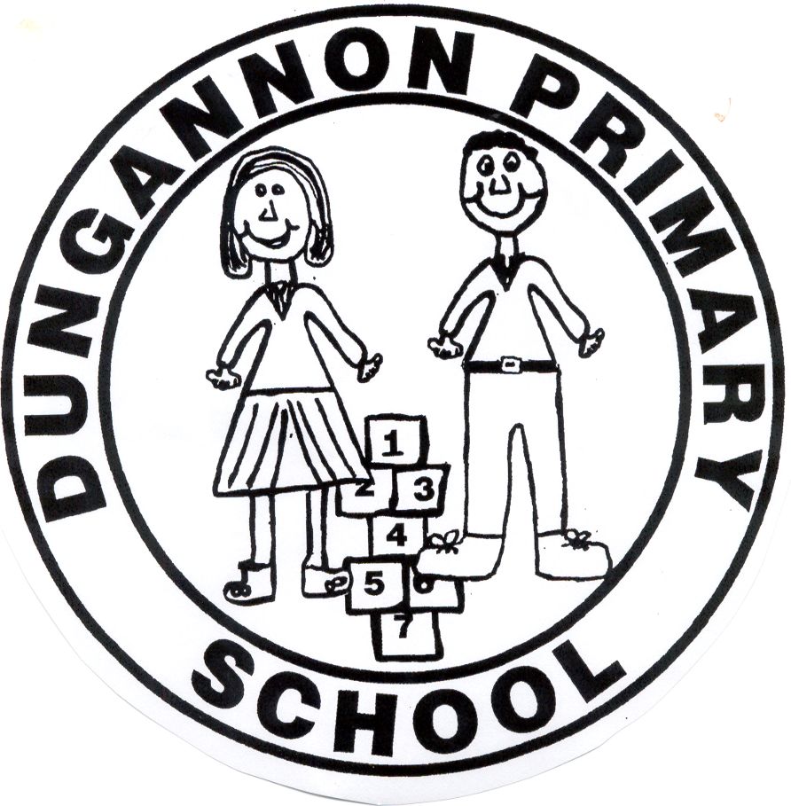

Relationships & Sexuality
Policy

Dungannon Primary School
Relationships and Sexuality Education (RSE) Policy

Definition

Relationships and Sexuality Education (RSE) is a lifelong process which encompasses the acquisition of knowledge, understanding and skills and the development of attitudes, beliefs and values about personal and social relationships and gender issues. The learning process begins informally with our parents (or those holding parental responsibility) long before any formal education takes place at school.

“Sexuality includes all aspects of the human person that relate to being male or female and is subject to change and development throughout life. Sexuality is an integral part of the human personality and has biological, cultural, psychological, social and spiritual dimensions. It especially concerns affectivity, the capacity to give and receive love; procreation and, in a more general way the aptitude for forming relationships with others. It is a complex dimension of human life and relationships.” CCEA Guidance for Primary Schools, Relationships and Sexuality Education 2001.

Rationale

The Education Reform (Northern Ireland) Order 1989 further set out the legislative basis, requiring all grant aided schools to offer a curriculum which:

- promotes the spiritual, moral, cultural, intellectual and physical development of pupils at the school and thereby of society.
- prepares such pupils for the opportunities, responsibilities and experiences of adult life

Our programme of RSE will not be value free; it will provide a framework of values and ideals within which the children will be given positive messages about family life, relationships and responsibilities, reflecting the Christian ethos that permeates the work of the school.
We further recognise the importance of working in partnership with parents/carers in this area of personal development and acknowledge the contribution that can be made by outside agencies with skill and expertise in particular areas of the curriculum (eg Love for Life, Women’s Aid and School Nursing Service).
INTRODUCTION

RSE is a statutory part of the NI curriculum and is delivered through RE, Health Education, PDMU, PE, The World Around Us, Assemblies etc. In Dungannon Primary School, RSE is taught mainly through the medium of PDMU in the Personal Understanding and Health Strand.

In RSE all pupils will be taught in an atmosphere of mutual respect. The value of a stable family life will be presented. As they mature, pupils will be encouraged to appreciate the importance of self-discipline, dignity, respect for themselves and others. Through PDMU and the World Around Us children will learn about changes in their bodies as they grow older and, in Primary 7, will be given the opportunity to learn about puberty in order to prepare them for the emotional and physical changes they may expect to experience over the next few years. The teaching arrangements for this will be single gender groups. This will be addressed through the Love for Life programme.

RSE should enable pupils to clarify what they believe and why they believe it and develop a respect for and interest in the beliefs of others. Pupils need opportunities to explore values and attitudes and to consider how they, and others, are affected by them.

Teaching at all times will be appropriate to the maturity and level of understanding of the pupils concerned. Teachers will be aware of, and take into account, the variety of existing pupil knowledge, the different attitudes and beliefs and the pupil’s capacity to understand the issues.
Sexuality includes all aspects of the human person that relate to being male or female and is subject to change and development throughout life. Sexuality is an integral part of the human personality and has biological, cultural, psychological, social and spiritual dimensions. It especially concerns affectivity, the capacity to give and receive love; procreation and, in a more general way, the aptitude for forming relationships with others. It is a complex dimension of human life and relationships.

Teaching RSE should provide opportunities which enable pupils:

- to form values and establish behaviour within a moral, spiritual and social framework;
- to examine and explore the various relationships in their personal lives;
- to learn how to develop and enjoy personal relationships and friendships which are based on responsibility and mutual respect;
- to build the foundations for developing more personal relationships in later life;
- to make positive, responsible choices about themselves and others and the way they live their lives.

AIMS

The aims of RSE are to:

- enhance the personal development, self-esteem and well-being of the child;
- help the child develop healthy and respectful friendships and relationships;
- foster an understanding of, and a healthy attitude to, human sexuality and relationships in a moral, social and spiritual framework;
- promote responsible behaviour and the ability to make informed decisions;
- help the child come to value family life. promote an appreciation of the value of human life

LEARNING OBJECTIVES

The RSE curriculum should enable pupils to:

- acquire and develop knowledge and understanding of self;
- develop a positive sense of self-awareness, self-esteem and self-worth;
- develop an appreciation of the dignity, uniqueness and well-being of others;
- understand the nature, growth and development of relationships within families, in friendships

Within a wider context, pupils will be enabled to:

- develop an awareness of differing family patterns;
- develop strategies to make decisions, solve problems, and implement actions in various personal, social and health contexts;
- become aware of the variety of ways in which individuals grow and change and understand that their developing sexuality is an important aspect of self-identity;
- develop personal skills which will help to establish and sustain healthy personal relationships;
- develop some coping strategies to protect self and others from various forms of abuse;
- acquire and improve skills of communication and social interaction;
- acquire and use an appropriate vocabulary to discuss feelings, sexuality, growth and development;
- develop a critical understanding of external influences on lifestyles and decision making.

SKILLS

The RSE curriculum should enable pupils to develop the skills necessary to form and maintain relationships and to make informed choices and decisions regarding health and well-being.
Pupils should also be helped to develop skills to critically evaluate the wide range of information, opinions, attitudes and values. They need opportunities to develop:

- practical skills for everyday living and for supporting others
- communication skills learning to listen, listening to others’ points of view; putting one’s own view forward clearly and appropriately; giving and receiving feedback; handling and resolving conflict peacefully; being assertive;
- decision-making and problem-solving skills for sensible choices made in the light of relevant information; making moral judgements about what to do in actual situations and putting these judgements into practice; acting responsibly and with initiative as an individual or as a member of a variety of groups;
- inter-personal skills for managing relationships confidently and effectively; for developing as an effective group member or leader.

OTHER RELEVANT POLICIES AND PROCEDURES

The school has a duty to ensure that safeguarding permeates all activities. This policy therefore complements and supports a range of other school policies and procedures for:

- Pastoral Care
- Positive Behaviour
- Special Educational Needs
- E-Safety
- Attendance
- Induction
- Drug Education
- Health and Safety
- Intimate Care
- Educational Visits
- Safeguarding & Child Protection

These policies are available to parents and any parent requiring a copy should contact the School Principal or visit the school website.

DELIVERING THE RSE PROGRAMME

The current situation is that requirements of RSE are being taught through RE, Health Education, PDMU, PE, The World Around Us, Assemblies, and in any other appropriate areas of the curriculum. The programme will be available to all pupils, including those with Special Educational Needs.

All teachers will be responsible for teaching RSE. It is particularly important for teaching staff to be aware of the fact that physical development may outstrip emotional maturity and to accommodate this disparity in class lessons and experiences. If any disclosures are made, confidentiality will be maintained and teachers will follow agreed procedures set out the Child Protection Policy.

Parents reserve the right to withdraw their children from RSE lessons. The school will provide alternative arrangements for pupils who are removed from part or the entire RSE programme.

Communicating with Others

All teaching staff have been involved in agreeing age appropriate language and statements likely to arise through the teaching of RSE, and how to deal with sensitive issues and questions.
This policy has been approved by the Board of Governors and is available on the school’s website.

MONITORING, EVALUATING AND REVIEWING THE RSE POLICY

Dungannon PS staff are committed to monitoring and evaluating the effectiveness of this policy. Specifically important to the RSE Programme are:

- pupil feedback
- staff review and feedback
- parental feedback
- further Departmental guidance and legislative changes
This policy will be reviewed as necessary.

Staff Training
Where appropriate, staff will receive relevant training. This will be in keeping with the ethos of the school and statutory guidelines from CCEA. Past practice and skills from other areas of the curriculum eg RE, Health Education, PDMU, PE, The World Around Us, Assemblies etc will be utilised when possible.

Roles and Responsibilities

Board of Governors

- BOG works in collaboration with teachers and parents
- Examines and approves the policy
- Reviews the policy
- Has a sensitivity towards the Christian ethos and cultural setting of the school

Principal

- Consults with the Governors, staff, parents and appropriate outside agencies
- Supports co-ordinators in reviewing appropriate policies.

Role of Co-ordinator – Miss Wilson
- Be familiar with statutory content
- Draw up and review policy
- Contact outside agencies
- Attend relevant training and disseminate to staff
- Monitor programme
- Liaise with Principal in implementing any changes
- Inform parents of the RSE programme

Staff

- Have a complementary role alongside parents
- Attend training where and when appropriate
- Plan, develop and implement an RSE programme of study

1. Circulars relating to RSE

The general principles which underpin our work in Dungannon Primary School are those set out in Departmental guidance and the following Circulars:

Circular 2001/15: Relationships and Sexuality Education (RSE)
Circular 2001/15-2: Guidance for Primary Schools - Relationships and Sexuality Education (RSE)
Circular 2010/01: Guidance on Relationships and Sexuality Education (RSE)
Circular 2013/16: Relationships and Sexuality Education Policy in Schools
Circular 2015/22: Relationships and Sexuality Education (RSE) Guidance

The following includes extracts from the N.I. Primary Curriculum -
Personal Development and Mutual Understanding
Strand - Personal Understanding and Health

Foundation Stage

Self-Awareness - Exploring who they are, what they can do, identifying favourite things, what makes them special

Feelings and Emotions

- beginning to recognise how they feel
- knowing what to do if sad or lonely, afraid or angry
- telling others about feelings
- realising what makes people sad or unhappy, recognising how people feel

Health and Safety

- Being aware of caring for his/her own body
- recognising good hygiene practices
- understanding growth and change
- exploring appropriate personal safety strategies, road safety,
- medicines and drugs -safety rules

Key Stage 1
Self-Awareness
- Feeling positive about oneself
- awareness of own strengths, abilities, qualities, personal preferences
- recognising own feelings and emotions
- recognising and managing the effects of strong feelings – anger, sadness, loss
- acknowledging that everyone makes mistakes
- recognising how they can develop and improve learning

Health, Growth and Change
- Recognising and valuing the options for a healthy lifestyle
- having respect for their bodies and those of others
- being aware of the stages of human growth and development
- recognising how responsibilities and relationships change as you grow older
- understanding medicines and drugs
- understanding that, if not used properly, all products can be dangerous
- being aware that some diseases are infectious and some can be controlled

Key Stage 2
Self-Awareness
- developing self-awareness, self-respect and self-esteem
- confidently express own views and opinions
- identify current strengths and weaknesses
- face problems and try to resolve them
- examine and explore own and others’ feelings and emotions
- recognise, express and manage feelings in a positive and safe way
- develop insight into potential and capabilities
- reflect on progress and set goals
- identify and practise effective learning strategies
- be aware of different learning styles

Health, Growth and Change
- understand the benefits of a healthy lifestyle
- recognise what shapes positive mental health
- know about the harmful effects of tobacco, alcohol and other illicit and illegal substances
- understand that bacteria and viruses affect health and know that basic routines can be followed to minimise risks
- know how the body grows and develops
- be aware of physical and emotional changes that take place during puberty (Y7 only)
- be aware of the skills and importance of good parenting
- recognise how responsibilities change as they become older and more independent

Keeping Safe
- develop strategies to resist peer pressure
- recognise the nature of bullying and the harm which can result
- become aware of the potential danger from strangers and how their attention can make you uncomfortable
- recognise appropriate road use
- develop a pro-active and responsible approach to safety – at home, near water, on the internet, TV etc
- know where, when and how to seek help
- being aware of basic emergency procedures and first aid

This policy was drawn up following consultation with parents, pupils, staff and Governors.

This policy is available to download via the school website.

This policy will be reviewed every 3 years or when updated advice is presented by EA or DENI.

Ratified by Governors on Monday 20th January 2020.

